Purchase order Quote Delivery note

|  |  |
| --- | --- |
| Enterprise: NAME + LEGAL FORM | Contact: CONTACT PERSON |
| VAT: BE XXXX.XXX.XXX | Delivery date: CLICK HERE TO ENTER A DATE |
| Address: STREET + N°, POSTAL CODE, CITY, COUNTRY | Delivery address: STREET + N°, POSTAL CODE, CITY, COUNTRY |
| Telephone: PREFIX + NUMBER | Email: XXXX@XXXX.XXX |

**bdc/quote/bdl number:Do not complete ! Reserved for MBC-Solutions**

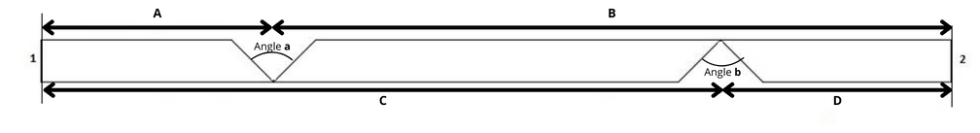

Number of plates: Indicate here the desired quantity

Length:  2600mm /  2800mm /  3000mm

Plate type:  A /  RF /  WR

Rated cut: 1.  ABA /  GBC

2.  ABA /  GBC

Thickness: 10mm / 12.5mm / 15mm / 18mm

Angle: **a**:  45° /  90° -- **b**:  45° /  90°

|  |  |  |  |
| --- | --- | --- | --- |
| **A** | **B** | **C** | **D** |
| MEASURE **mm** | MEASURE **mm** | MEASURE **mm** | MEASURE **mm** |

Extra notes: …...........................