☐Purchase order ☐Quote ☐Delivery note
Enterprise: NAME + LEGAL FORM | Contact: CONTACT PERSON
VAT: BE XXXX.XXX.XXX | Delivery date: CLICK HERE TO ENTER A DATE
Address: STREET + N°, POSTAL CODE, CITY, COUNTRY | Delivery address: STREET + N°, POSTAL CODE, CITY, COUNTRY
Telephone: PREFIX + NUMBER | Email: XXXX@XXXX.XXX

bdc/quote/bdl number:Do not complete! Reserved for MBC-Solutions

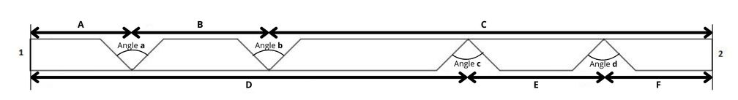

Number of plates: Indicate here the desired quantity

Length: ☐ 2600mm / ☐ 2800mm / ☐ 3000mm

Plate type: ☐ A / ☐ RF / ☐ WR

Rated cut: 1. ☐ ABA / ☐ GBC
2. ☐ ABA / ☐ GBC

Thickness: ☐ 10mm / ☐ 12.5mm / ☐ 15mm / ☐ 18mm

Angle: a: ☐ 45° / ☐ 90° -- b: ☐ 45° / ☐ 90° -- c: ☐ 45° / ☐ 90° -- d: ☐ 45° / ☐ 90°

A | B | C | D | E | F
MEASURE mm | MEASURE mm | MEASURE mm | MEASURE mm | MEASURE mm | MEASURE mm

Extra notes: ..............................

